# Raspberry Pi

|  |  |
| --- | --- |
| Family | Model |
| Raspberry Pi | B |
| A |
| B+ |
| A+ |
| Raspberry Pi 2 | B |
| Raspberry Pi Zero | Zero |
| W / WH |
| 2 W |
| Raspberry Pi 3 | B |
| A+ |
| B+ |
| Raspberry Pi 4 | B |
| 400 |
| Raspberry Pi Pico | Pico |
| W |
| 2 |
| Raspberry Pi 5 | |

**Raspberry Pi** is a low-cost, single-board computer (SBC) that's about the size of a credit card

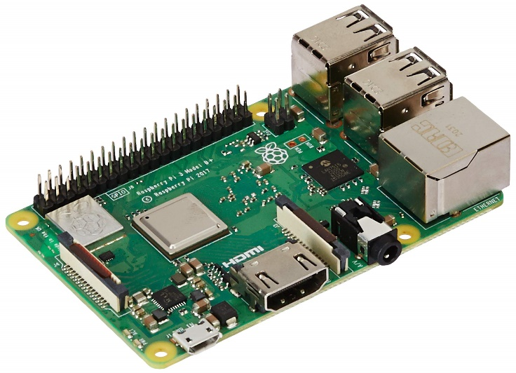**Purpose**

The Raspberry Pi was developed to make computer science more accessible and affordable. It's used by people of all ages to learn how to program and explore computing.

**Uses**

The Raspberry Pi is used for a variety of purposes, including:

* + Robotics
  + Home automation
  + Industrial automation
  + Computer and electronic hobbyists

# History and Evolution

The Raspberry Pi was originally developed in the UK by the Raspberry Pi Foundation in association with Broadcom. The original model became more popular than expected, selling outside its target market. In 2012, it became the best-selling British computer.

The name Raspberry Pi comes from the bold color of the raspberry and the word "Pi" as a play on the word "Python".

**Timeline of Raspberry Pi Models:**

* + **2012:** Raspberry Pi 1 (Model A & B)
  + **2015:** Raspberry Pi 2
  + **2016:** Raspberry Pi 3
  + **2019:** Raspberry Pi 4
  + **2020:** Raspberry Pi Pico
  + **2023:** Raspberry Pi 5

# Technical Specifications

**Processor:** Broadcom BCM2712 2.4GHz quad-core 64-bit Arm Cortex-A76 CPU

**Memory:** LPDDR4X-4267 SDRAM with options for 2GB, 4GB, or 8GB

**Connectivity:**

* Dual-band 802.11ac Wi-Fi and Bluetooth 5.0 / BLE
* Gigabit Ethernet with PoE+ support (requires separate PoE+ HAT)

**Storage:** MicroSD card slot with high-speed SDR104 mode

**Power:** USB-C power supply: 5V/5A with Power Delivery support

**I/O Ports:**

**USB Ports:**

* 2 × USB 3.0 (supporting simultaneous 5Gbps operation)
* 2 × USB 2.0

**Camera/Display:**

* 2 × 4-lane MIPI camera/display transceivers

**PCIe Interface:**

* PCIe 2.0 x1 for fast peripherals (requires separate adapter)

**Graphics & Video:**

* VideoCore VII GPU, supporting OpenGL ES 3.1 and Vulkan 1.2
* Dual 4Kp60 HDMI display output with HDR support
* 4Kp60 HEVC hardware decoder

**Additional Features:**

* Standard 40-pin GPIO header
* Real-Time Clock (RTC) powered by an external battery
* Power button for easy control

**Production Lifetime:**

* Guaranteed production until at least January 2036

# Raspberry PI 5 board

### **Top Left:**

1. **SRAM (1GB, 2GB, 4GB, or 8GB)**: This is the system memory used by the CPU for processing tasks. Different configurations allow users to choose according to their needs.
2. **BCM2712 Processor**: A quad-core ARM Cortex-A76 CPU, providing high performance for demanding applications like AI, IoT, and multimedia.
3. **Dual-band 802.11ac Wireless + Bluetooth 5**: Provides Wi-Fi connectivity for internet access and Bluetooth 5.0 for wireless communication with peripherals.
4. **PCI Express Interface**: Allows expansion cards like SSDs or high-speed peripherals to be connected, enhancing storage and performance capabilities.

### **Middle Left:**

1. **On/Off Button**: A dedicated power button for easy control of turning the device on and off without disconnecting the power source.
2. **PMIC (Power Management IC)**: Manages power distribution across various components of the board, ensuring stable and efficient energy usage.
3. **UART Connector**: Used for serial communication, typically to interface with other devices like microcontrollers or debug systems.

### **Bottom Left:**

1. **USB-C Power Jack**: The primary power input, using a USB-C connector for improved power delivery and ease of use.
2. **RTC (Real-Time Clock) Battery Connector**: Allows connection of a backup battery to maintain the system clock when powered off.
3. **2 × Micro-HDMI**: Supports dual-display output with up to 4K resolution, useful for multimedia and advanced graphical applications.

### **Top Right:**

1. **Raspberry Pi RP1 I/O Controller**: A custom chip handling general-purpose I/O (GPIO), allowing flexible input/output capabilities.
2. **Fan Connector**: Provides power and control to an external cooling fan to keep the board cool under heavy workloads.

### **Middle Right:**

1. **2 × USB 2.0 Ports**: Standard USB ports for connecting peripherals like keyboards, mice, or USB drives with moderate speed requirements.
2. **2 × USB 3.0 Ports**: High-speed USB ports for faster data transfer, ideal for external hard drives, high-speed storage devices, or cameras.
3. **Ethernet Transceiver**: Converts data between digital and analog signals for wired network communication.
4. **Ethernet Jack**: A standard RJ45 port for wired internet connections, offering high-speed and reliable networking.
5. **PoE HAT Connector**: Supports Power over Ethernet (PoE) HATs for powering the device via the Ethernet cable.

### **Bottom Right:**

1. **2 × 4-lane MIPI DSI/CSI Connectors**: Interfaces for connecting display panels (DSI) and camera modules (CSI), supporting high-quality visuals and image processing.

# Programming with Raspberry Pi

**Supported Languages**

* Python, C/C++, Java, Scratch, Node.js, Ruby

**Operating Systems**

* Raspberry Pi OS (Debian-based, optimized for Pi 5)
* Ubuntu, Windows IoT Core, RetroPie

**Development Tools**

* + **IDEs:** Thonny (Python), VS Code, PyCharm, Geany, IDLE
  + **Features:**
    - GPIO programming with RPi.GPIO and gpiozero
    - Dual 4K display support for visualization
    - Accelerated AI with TensorFlow Lite

## Sample Programs: Blinking LED

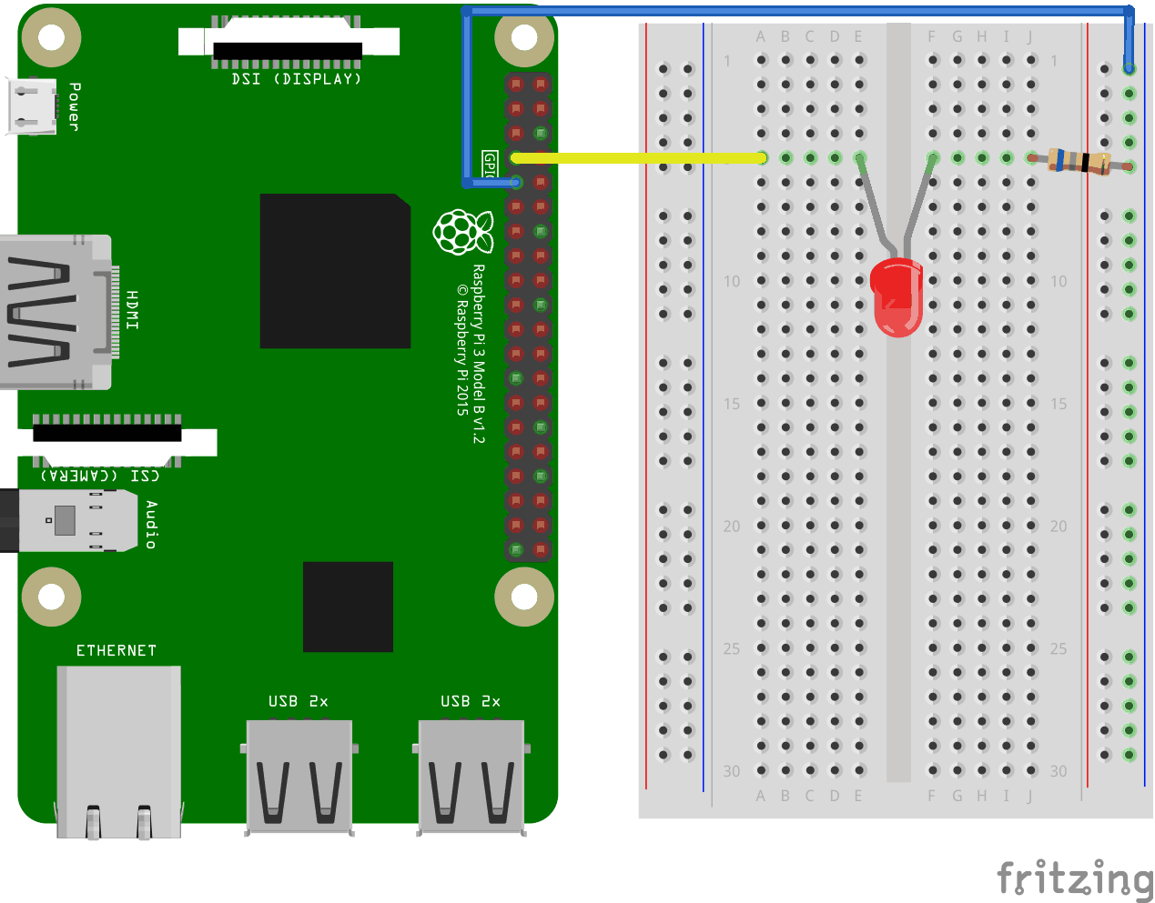

### **Hardware Connections:**

1. **Raspberry Pi GPIO Pinout:**
   * **Pin 18 (GPIO 18)**: Connected to the positive (anode) leg of the LED via a yellow jumper wire. This pin will control the LED's state (on/off).
   * **GND (Ground Pin)**: Connected to the negative (cathode) leg of the LED through a **resistor** to complete the circuit and prevent overcurrent to the LED.
2. **LED Circuit:**
   * **Resistor**: Used in series with the LED to limit the current and protect the LED from damage.
   * **Breadboard**: Simplifies connections between the Raspberry Pi and the LED by providing a common ground and linking components.

### **Python Code:**

import RPi.GPIO as GPIO

import time

GPIO.setmode(GPIO.BCM) # Sets the pin numbering system to BCM (Broadcom chip-specific pin numbers).

GPIO.setup(18, GPIO.OUT) # Configures GPIO pin 18 as an output pin.

while True: # Infinite loop to keep the LED blinking.

GPIO.output(18, GPIO.HIGH) # Turns the LED on by sending a HIGH signal to pin 18.

time.sleep(1) # Waits for 1 second.

GPIO.output(18, GPIO.LOW) # Turns the LED off by sending a LOW signal to pin 18.

time.sleep(1) # Waits for 1 second.

### **How It Works:**

1. **GPIO Initialization**:
   * The GPIO.setmode(GPIO.BCM) line sets the GPIO pin numbering system to **BCM** mode, which uses the physical pin numbers of the Broadcom chip.
   * GPIO.setup(18, GPIO.OUT) configures **pin 18** as an **output** pin.
2. **Infinite Loop**:
   * The program enters a while True loop, continuously alternating the state of GPIO pin 18 between **HIGH** (on) and **LOW** (off).
   * The time.sleep(1) function pauses the loop for **1 second**, creating a blinking effect.

# Current Applications of Raspberry Pi 5

* **Space Research:** Used in programs like the European Astro Pi Challenge to run experiments aboard the ISS.
* **Portable Health Monitoring:** Non-invasive devices for monitoring vitals like heart rate and oxygen levels.
* **DIY Kits:** Encouraging hands-on learning for students through robotics and automation projects.
* **Home Media Servers:** Hosting and streaming personal content using software like Plex.Gaming
* **Consoles:** Emulating classic games with RetroPie.
* **Smart Agriculture:** Raspberry Pi-powered irrigation systems in India and Africa.
* **Google AIY Projects:** Custom AI solutions using Raspberry Pi.

# Why Raspberry Pi Stands Out?

**1. Cost-Effectiveness:**

* + Affordable compared to alternatives like Arduino with shields or Intel NUCs.
  + Models start as low as $5 (Pico) and offer high performance for the price.

**2. Versatility:**

* + Functions as a mini-PC, IoT device, robotics controller, or media center.
  + Supports multiple operating systems (Raspberry Pi OS, Ubuntu, etc.).

**3. Broad Community Support:**

* + Extensive online forums, tutorials, and open-source projects.
  + Easily accessible libraries and tools for development.

**4. Performance and Hardware Features:**

* + Latest models (e.g., Raspberry Pi 5):
    - Quad-core CPU, dual 4K output, PCIe support, and AI acceleration.
    - Better memory options (up to 8GB) than most microcontrollers.

**5. Compatibility with Peripherals:**

* + Standard GPIO pins and support for sensors, cameras, and displays.
  + USB, Ethernet, and Wi-Fi/Bluetooth for enhanced connectivity.

**6. Ease of Use:**

* + Pre-installed software (Raspberry Pi OS) makes it beginner-friendly.
  + Plug-and-play setup, ideal for all skill levels.

**7. Rich Ecosystem:**

* + **Hardware Kits:** Available from trusted brands like CanaKit and Vilros.
  + **Accessories:** Camera modules, HATs, and PoE adapters expand functionality.

**8. Real-World Adoption:**

* + Widely used in education, IoT, healthcare, and research projects.
  + Trusted by industries for prototyping and deployment.

**9. Sustainable Production:**

* + Long production lifetimes (e.g., Raspberry Pi 5 guaranteed until 2036).
  + Energy-efficient, reducing power costs and environmental impact.

# Comparison to Alternatives

|  |  |  |  |  |  |
| --- | --- | --- | --- | --- | --- |
| **Feature** | **Raspberry Pi** | **Arduino** | **BeagleBone** | **Intel NUC** | **Tiva C Series** |
| **Price** | Low | Very Low | Medium | High | Medium |
| **Performance** | High | Low | Medium | Very High | Medium |
| **Ease of Use** | Very Easy | Moderate | Moderate | High | Moderate |
| **Community Support** | Extensive | High | Limited | Moderate | Moderate |
| **Use Cases** | IoT, AI, Media | Robotics, Sensors | Industrial, IoT | Mini-PC, Servers | Embedded Systems, Robotics |